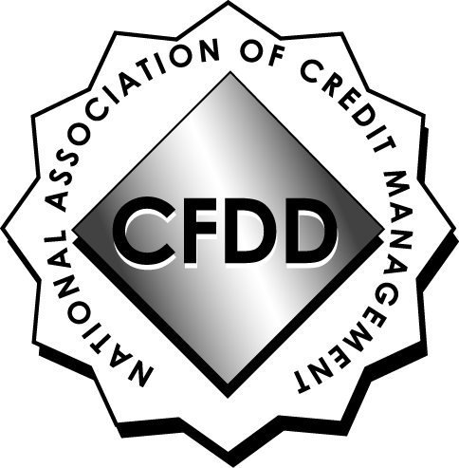

NACM - CFDD

CREDIT & FINANCIAL DEVELOPMENT DIVISION OF NACM®

KANSAS CITY CHAPTER

NEW MEMBER APPLICATION

DATE:

NAME:

TITLE:

COMPANY:

ADDRESS:

CITY/STATE: ZIP:

PHONE: FAX:

E-MAIL ADDRESS:

NACM Member (required) Yes No Name of Affiliate:
Affiliate Primary Member Yes No

NACM Designations CCE CBF CBA CICP ICCE CCRA

Please return by email to: Nancy Watson-Pistole CCE ICCE
Nancy.watsonpistole@gmail.com

Upon receipt of your completed membership application, you will receive an invoice for annual dues, pro-rated depending on the month you join. Your name will be added to the membership roster upon receipt of payment.

WELCOME TO CFDD!

